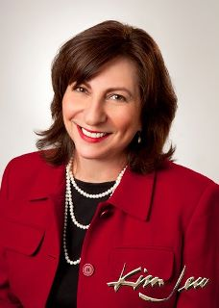

*Insert list of volunteer involvement and associated years here.*

*Bylaws Committee Member 2009-2013*

*Executive Council Member at Large*

*Secretary2012/2013*

*Developed Board Photo Roster*

*Governance Committee Chair 2013-2014*

*Governing Document Realignment Task Force 2013*

*Strategic Visioning Chair 2014*

*Chair-elect 2013/2014*

*Nominating Committee Chair 2016*

*Legacy Task Force 2016, 2017*

2015

2016

Chair

Mary DeLorenzo

New Mexico